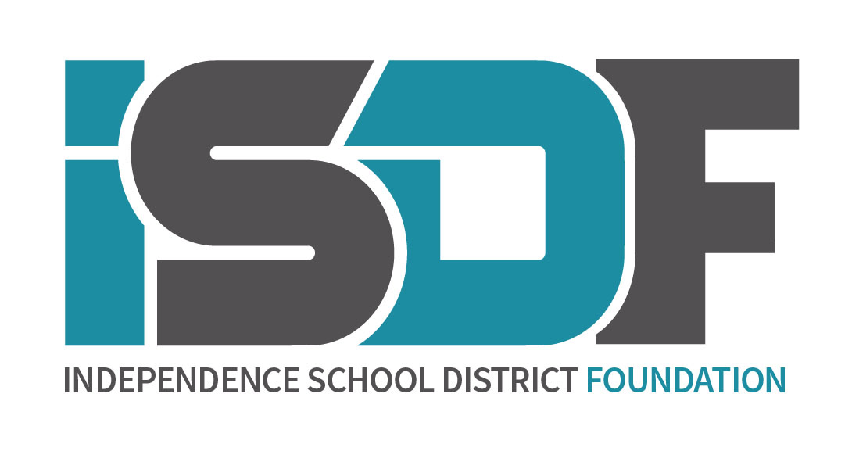

Van Horn STEMS Scholarship $500
One scholarship awarded

School: Van Horn

Summary: The math and science teachers at Van Horn High School wish to encourage students who are interested in pursuing a career in a math or science field. To qualify for this award, the applicant must plan to major in a STEM degree (science, technology, engineering, math). The student must have taken a math, science or technology course each year of high school to be eligible for this scholarship.

Examples of STEM degrees include :
- Engineering
- Physical Science
- Geoscience
- Math and Computer Science
- Life Science
- Science and Engineering Technologies

APPLICATION INFORMATION:
Criteria / Requirements:
- Completion of the Scholarship Application
- Completion of the Supplemental Page
- Transcript with ACT/SAT Composite
- Declare major in math or science field (see examples above)
- Scholarship must be paid out during the first academic semester following high school graduation. Exceptions must be submitted in writing and approved by the School District of Independence Foundation, Inc. Board of Directors

Selection: Recommendation of recipients are made under the direction of the Van Horn Math and Science Department. Approval of recipient is made by the Board of Directors of the School District of Independence Foundation, Inc.

